Magnitude Comparator is a combinational circuit capable of comparing the relative magnitude of two binary numbers. It is one of the two types of digital comparator.
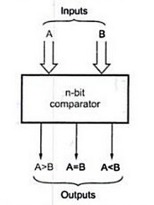

Figure (a): Block diagram of n-bit comparator
Figure (a) shows the block diagram of n-bit magnitude comparator. It accepts two n-bit binary numbers, say A and B as inputs and produces on
Input A, B then outputs: A>B, A=B and A<B.
One of the outputs will be high depending upon the relative magnitude. That is, output A>B will be high if A is greater than B, output A=B will be high if A and B are equal, and output A<B will be high if A is less than B.

1-BIT Digital Comparator:-
Input |  | LT | EQ | GT
A | B | A>B | A=B | A<B
0 | 0 | 0 | 1 | 0
0 | 1 | 0 | 0 | 1
1 | 0 | 1 | 0 | 0
1 | 1 | 0 | 1 | 0
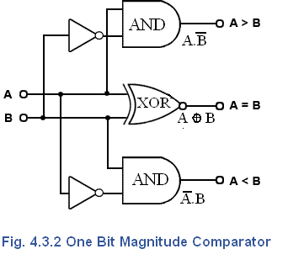

Applications
Combinational circuits are widely used in electronic systems. They are used to carry out arithmetic operations in digital systems such as computers and calculators. They are also used in navigation systems and robots.

2-BIT Digital Comparator:-
